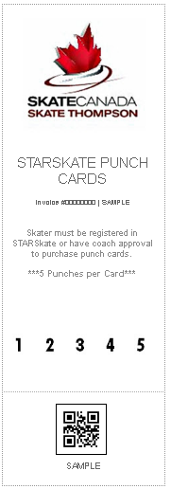
STARSkate Punch Cards - $75
This year all punch cards will be purchased online at www.skate-thompson.com.
*Skater must be registered in a program.
To purchase a punch card follow the steps below:
- Navigate to the REGISTRATION tab
- Under QUICK NAVIGATION click on PURCHASE OTHER PRODUCTS
- Put in quantity to order and ADD TO CART
- Proceed to checkout
To print and use the tickets:
- On your receipt, members can print individual tickets or all the tickets by clicking the print icons. The tickets will be in the "Products" section of the receipt.
- Member will also receive an email with their receipt that will include the option to print the tickets.
- Skater must get coach or board member to initial the punch card each time skater uses it.
Once tickets are complete:
- Please hand in all completed punch card to the drop box in the cage.
If you have any questions or concerns please email Skate Thompson thompsonskate@gmail.com.

